
HCG One Step Pregnancy Test Midstream
Package Insert
Reagent Cat: | HCG-103B | Instrument Cat: | DFT101
Specimen: | Urine
Version: | Z | Effective Date: | 2021-04-15
For Self-Testing.
【INTENDED USE】
The HCG One Step Pregnancy Test Midstream is a rapid, one-step lateral flow immunoassay in midstream format with DFT101 Digital Fertility Tracker for the qualitative detection of human chorionic gonadotropin (hCG) in urine, as an early detection of pregnancy.
【SUMMARY】
Human chorionic gonadotropin (HCG) is produced by the syncytiotro-phoblast secreted by the placental chorion during pregnancy. In mature women, the fertilized eggs move into the uterine cavity and are implanted into the uterus. During the development of the fetus, the syncytiotrophoblast cells of the placenta produce a large amount of hCG, which can be excreted into the urine through the blood circulation of pregnant women. The hCG levels in serum and urine increased rapidly from 1 to 2.5 weeks of gestation, peaked at the 8th week of pregnancy, and then decreased to the medium level at the 4th month of pregnancy, and maintained until the end of pregnancy. The examination of hCG is of great signifcance in the diagnosis of early pregnancy, and has certain value in the diagnosis, different diagnosis and course observation of diseases related to pregnancy and trophoblastic tumor.
For self-testing and in vitro diagnostic use only.
【REAGENTS】
The test contains anti-HCG particles and anti-HCG antibody coated on the membrane.
【PRECAUTIONS】
- For Self-Testing. Do not use after the expiration date.
- Do not eat, drink or smoke in the area where the specimens or kits are handled.
- Do not use test if pouch is damaged.
- Handle all specimens as if they contain infectious agents. Observe established precautions against microbiological hazards throughout the procedure and follow the standard procedures for proper disposal of specimens.
- The used test should be discarded according to local regulations.
- Humidity and temperature can adversely affect results.
- Keep out of the reach of children.
【STORAGE AND STABILITY】
Store as packaged in the sealed pouch either at room temperature or refrigerated (2-30°C). The test is stable through the expiration date printed on the sealed pouch. The test must remain in the sealed pouch until use. DO NOT FREEZE. Do not use beyond the expiration date.
【SPECIMEN COLLECTION AND PREPARATION】
The urine specimen must be collected in a clean and dry container. Urine collected at morning of the day may be used. Urine specimens exhibiting visible particles should be centrifuged, filtered, or allowed to settle to obtain clear specimen for testing.
Collected urine specimens must be put in clear and dry containers. Ensure that enough of the specimen is collected to allow submerging the dipping area of the device.
Perform the testing immediately after the specimen collection. Do not leave the specimens at room temperature for prolonged periods.
【MATERIALS】
Materials Provided
- Test Midstream (s) | - Package insert | - Desiccant
Materials Required but Not Provided
- Specimen Collection Container | - Timer
【HOW TO USE】
Step 1: Remove the battery cover. Install the button cell in the direction as indicated. When you hear a beep, it indicates that the battery has been inserted successfully.
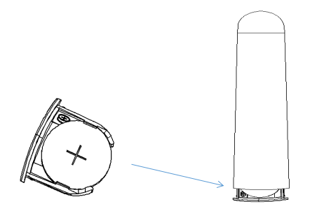
Step 2: Collect your urine in the cup included in the package. You can choose the urine from any of the three different time of the day - morning, afternoon and evening.

Step 3: Remove the lid of the main body. When you hear a beep or All lights are on (The indicator light goes out after 2S), it indicates that DFT101 is on. Remove the test midstream cover and insert the test midstream into the device. (Please make sure that the test midstream is inserted all the way to the bottom and the whole arrow has disappeared.) In the left indicator area, the indicator light will flash alternately.
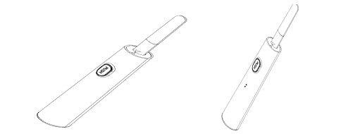
Step 4: Collect urine in user prepared containers. Dip the top of the test midstream into the Urine or if you don’twant to collect urine，please downward directly into your urine stream for at least 10-15 seconds.
and hold it until you hear a “beep” (In the left and right indication area, the indicator light will flash left and right circularly). Then pull it out and put the test midstream lid back on.
Note: But don’t drink too much liquid before testing.

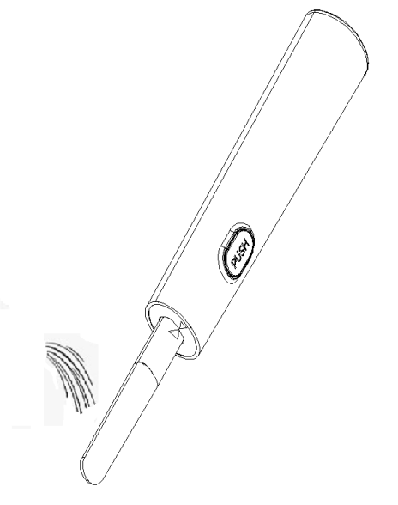

Step 5: Place the product on a flat surface. In the left and right indication area, the indicator light will flash left and right circularly during the testing. Wait for about 6-10 minutes till you hear three beeps which indicate that the test is completed. The test result will be out the test strip or putting back & pulling out the main body lid again will enable the last test result to show again.

.
【TEST RESULT】
The measurement result will be displayed for 30 seconds.

Symbol “-"
Indicates a negative result with a low probability of conception.
For hCG,"-" means non pregnant.

Symbol white ""
you can assume that you are pregnant once White “” is displayed. At the same time, you can check the gestational weeks "1-2, 2-3, 3 +".
Symbol red ""
If red "" is displayed, it means that the instrument has an error;
Errors in detection may be due to:
·The the test midstream is not placed in a downward position, or the dipstick is not placed horizontally after urination.
·use too much or too little urine.
You should use a new dipstick to retest and follow the instructions.
If the red""continues to flash, replace the battery.

【LIMITATIONS】
1. This product is only for testing human urine.
2. This product only provides qualitative detection of human chorionic gonadotropin (HCG) in the sample. If you need to detect the specific content of a certain index, please use relevant professional instruments.
3. Ingesting too much water before the test may cause false negative results. It is best to use morning urine test.
4. Taking certain fertility drugs containing HCG (such as Pregnyl, Profasi, Novarel, Ovidrel) will cause false positive results.
5. When the HCG concentration is high, the color band in the detection area may become lighter, which is a normal phenomenon.
6. If the subject is suspected of becoming pregnant and the urine test is negative, the morning urine can be collected again after 48-72 hours for re-testing.
7. Patients with uterine tumors, hydatidiform moles, abnormal pregnancy, endometrial hyperplasia, choriocarcinoma, and gastric cancer may have a positive result due to high levels of HCG in the urine.【PERFORMANCE CHARACTERISTICS】
Sensitivity and Accuracy
Laboratory studies show that the sensitivity of the HCG One Step Pregnancy Test Midstream is 25mIU/mL,100 mIU/mL and 500mIU/mL, the accuracy is 99.5%
Interference Substance
The following potentially interfering substances were added to HCG negative and positive specimens.
Analyte | Concentration | Analyte | Concentration
Acetaminophen | 20mg/dl | Glucose | 2g/dl
Acetylsalicylic acid | 20mg/dl | Hemoglobin | 10mg/dl
Ascorbic acid | 20mg/dl | Ampicillin | 20mg/dl
Atropine | 20mg/dl | Tetracycline | 20mg/dl
Caffeine | 20mg/dl | Bilirubin | 2mg/dl
Gentisic acid | 20mg/dl
Cross Reactivity
The HCG One Step Pregnancy Test Midstream has been tested with commonly known drugs and hormones including LH (500 mIU/mL), FSH (1000 mIU/mL), TSH (1000 μIU/mL). At the levels tested, none of these substances interfered with the expected test results.
【QUESTIONS & ANSWERS】
1.Q: How does the test work?
A: The hCG One Step Pregnancy Test Midstream detects a hormone in your urine that your body produces during pregnancy (hCG-human chorionic gonadotropin). The amount of pregnancy hormone increases as pregnancy progresses.
2.Q: How soon after I suspect that I am pregnant can I take the test?
A: You can test your urine as early as the first day you miss your period. You can perform the test anytime of the day; however, if you are pregnant, first morning urine contains the most pregnancy hormone.
3.Q: Do I have to test with first morning urine?
A: Although you can test at any time of the day, your first morning urine is usually the most concentrated of the day and would have the most hCG in it.
4.Q: How do I know that the test was run properly?
A: If there is an error, the machine will give an error signal.
5.Q: What should I do if the result shows that I am pregnant?
A: It means that your urine contains hCG and you are probably pregnant. See your doctor to confirm that you are pregnant and to discuss the steps you should take.
6.Q: What should I do if the result shows that I am not pregnant?
A: It means that no hCG has been detected in your urine and probably you are not pregnant. If you do not start your period within a week of its due date, repeat the test with a new test midstream. If you receive the same result after repeating the test and you still do not get your period, you should see your doctor.
You are encouraged to take the following steps to increase your chances for a healthy pregnancy and a healthy baby.
1.Use the hCG One Step Pregnancy Test Midstream to detect pregnancy when your period is late. You can begin better prenatal care as soon as you learn of your pregnancy.
2.If you get a positive result, it is advisable to visit your doctor immediately to begin your prenatal care.
3.Maintain a well-balanced diet, stop smoking, and reduce your intake of alcohol.
【BIBLIOGRAPHY】
1.Batzer FR. Hormonal evaluation of early pregnancy, Fertil. Steril. 1980; 34(1): 1-13
2.Catt KJ, ML Dufau, JL Vaitukaitis Appearance of hCG in pregnancy plasma following the initiation of implantation of the blastocyte, J. Clin. Endocrinol. Metab. 1975; 40(3): 537-540
3.Braunstein GD, J Rasor, H. Danzer, D Adler, ME Wade Serum human chorionic gonadotropin levels throughout normal pregnancy, Am. J. Obstet. Gynecol. 1976; 126(6): 678-681
4.Lenton EA, LM Neal, R Sulaiman Plasma concentration of human chorionic gonadotropin from the time of implantation until the second week of pregnancy, Fertil. Steril. 1982; 37(6): 773-778
5.Steier JA, P Bergsjo, OL Myking Human chorionic gonadotropin in maternal plasma after induced abortion, spontaneous abortion and removed ectopic pregnancy, Obstet. Gynecol.1984;64(3): 391-394
6.Dawood MY, BB Saxena,R Landesman Human chorionic gonadotropin and its subunits in hydatidiform mole and choriocarcinoma, Obstet. Gynecol. 1977; 50(2): 172-181
7.Braunstein GD, JL Vaitukaitis, PP Carbone, GT Ross Ectopic production of human chorionic gonadotropin by neoplasms, Ann. Intern Med. 1973; 78(1): 39-45

Index of Symbols
 | Consult instructions for use |  |  | Tests per kit |  |  | Authorized Representative
 | For in vitro  diagnostic use only |  |  | Use by |  |  | Do not reuse
 | Store between 2-30°C |  |  | Lot Number |  |  | Catalogue number
 | Manufacturer |  |  | Date of manufacturer |  |   0123 | Meet the requirements of 98/97/EC Directive
 | No exposure to the sun |  |  | No rain

Hangzhou Sejoy Electronics& Instruments Co.,Ltd.
Area C, Building 2, No.365, Wuzhou Road,Yuhang Economic
Development Zone,311100 Hangzhou City, Zhejiang,China
Website: www.sejoy.com


Shanghai International Holding Corp.GmbH (Europe)
Eiffestrasse 80, 20537 Hamburg, Germany
0123

