
LH One Step Ovulation Test Midstream
Package Insert
Reagent Cat: | LH-103B | Instrument Cat: | DFT101
Specimen: | Urine
Version: | Z | Effective Date: | 2021-04-15
For Self-Testing.
【INTENDED USE】
The LH One Step Ovulation Test Midstream is a rapid, one-step lateral flow immunoassay in midstream format with DFT101 Digital Fertility Tracker for the semi-qualitative detection of luteinizing hormone (LH) in urine, as an aid in predicting the time of ovulation, and peak fertility.
【SUMMARY】
Ovulation is the release of an egg from the ovary. The egg then passes into the fallopian tube where it is ready to be fertilized. For pregnancy to occur, the egg must be fertilized by sperm within 24 hours after its release. Immediately prior to ovulation, the body produces a large amount of luteinizing hormone (LH) which triggers the release of a ripened egg from the ovary. This “LH surge” usually takes place in the middle of the menstrual cycle.¹
The LH One Step Ovulation Test Midstream is a complete system to help predict the time of ovulation, and peak fertility. It is during this fertile time that pregnancy is most likely to occur.
The LH One Step Ovulation Test Midstream detects the LH surge in urine, signaling that ovulation is likely to occur in the next 24-36 hours. The test utilizes a combination of antibodies including a monoclonal LH antibody to selectively detect elevated levels of LH.
Important: The LH surge and ovulation may not occur in all cycles.
【REAGENTS】
The test contains anti-LH particles and anti-LH antibody coated on the membrane.
【PRECAUTIONS】
- For Self-Testing. Do not use after the expiration date.
- Do not eat, drink or smoke in the area where the specimens or kits are handled.
- Do not use test if pouch is damaged.
- Handle all specimens as if they contain infectious agents. Observe established precautions against microbiological hazards throughout the procedure and follow the standard procedures for proper disposal of specimens.
- The used test should be discarded according to local regulations.
- Humidity and temperature can adversely affect results.
- Keep out of the reach of children.
【STORAGE AND STABILITY】
Store as packaged in the sealed pouch either at room temperature or refrigerated (2-30°C). The test is stable through the expiration date printed on the sealed pouch. The test must remain in the sealed pouch until use. DO NOT FREEZE. Do not use beyond the expiration date.
【SPECIMEN COLLECTION AND PREPARATION】
- Determine the optimal time for urine collection. For best results, collect urine at about the same time each day. Some women have found that their best specimen is after 12 noon. Do not collect the first urine specimen after waking up.
- Reduce liquid intake approximately 2 hours prior to urine collection.
- Record the date, cycle day and time of urine collection. See the TEST RESULTS CHART at the end of this package insert.
【MATERIALS】
Materials Provided
- Test Midstream (s) | - Package insert | - Desiccant
Materials Required but Not Provided
- Specimen Collection Container | - Timer
WHEN TO START TESTING
First, determine the subject’s Menstrual Cycle Length. The Menstrual Cycle Length is the number of days from the first day of the subject’s period (menstrual bleeding) to the last day before the next period starts.
Next, determine the Days to Count Ahead after the period to start testing. Find the subject’s Menstrual Cycle Length on the first row of the chart below, and read the corresponding Days to Count Ahead in the second row. This is the number of days after the period to begin testing.
Menstrual Cycle Length
21 | 22 | 23 | 24 | 25 | 26 | 27 | 28 | 29 | 30 | 31 | 32 | 33 | 34 | 35 | 36 | 37 | 38
6 | 6 | 7 | 7 | 8 | 9 | 10 | 11 | 12 | 13 | 14 | 15 | 16 | 17 | 18 | 19 | 20 | 21
Days to Count Ahead
Finally, determine the day to start testing. Starting from and including the first day of the last period, count ahead the number of days indicated in the previous step. This is the day on which testing should begin. As a basic guideline, it is recommended to test once a day for five days.
Note: If uncertain about the length of the subject’s menstrual cycle, use the shortest menstrual cycle length (21 days) when reading the chart. In this case, it may be necessary to test for more than 5 days.
Example: The subject’s usual menstrual cycle length is 28 days. The chart indicates to count ahead 11 days from the subject’s last period. The subject’s last period started on the 3rd. Starting from and including the 3rd, count ahead 11 days to arrive at the 13th. Urine collection and testing should start on the 13th and proceed through the 17th. (See the Example Specimen Calendar below).
Example Specimen Calendar
Sun. | Mon. | Tue. | Wed. | Thu. | Fri. | Sat.
 | 1 | 2 | (3) | 4 | 5 | 6
7 | 8 | 9 | 10 | 11 | 12 | <13>
14 | 15 | 16 | 17 | 18 | 19 | 20
21 | 22 | 23 | 24 | 25 | 26 | 27
28 | 29 | 30 | 31
( ) -- First day of the last period
< > -- Begin testing with the LH One Step Ovulation Test Midstream
【HOW TO USE】
Step 1: Remove the battery cover. Install the button cell in the direction as indicated. Put the battery cover back in place. When you hear a beep, it indicates that the battery has been inserted successfully.
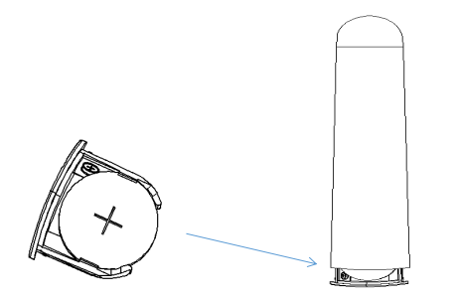

Step 2: Collect your urine in the cup included in the package. You can choose the urine from any of the three different time of the day - morning, afternoon and evening.
Step 3: Remove the lid of the main body. When you hear a beep or All lights are on (The indicator light goes out after 2S), it indicates that DFT101 is on. Remove the test midstream cover and insert the test midstream into the device. (Please make sure that the test midstream is inserted all the way to the bottom and the whole arrow has disappeared.) In the left indicator area, the indicator light will flash alternately

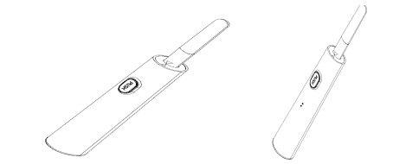
Step 4: Collect urine in user prepared containers. Dip the top of the test midstream into the Urine or if you don’t want to collect urine，please downward directly into your urine stream for at least 10-15 seconds,and hold it until you hear a “beep” (In the left and right indication area, the indicator light will flash left and right circularly). Then pull it out and put the test midstream lid back on.
Note: But don’t drink too much liquid before testing.

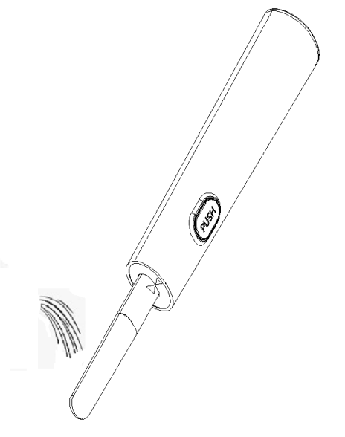
Step 5: Place the product on a flat surface. In the left and right indication area, the indicator light will flash left and right circularly during the testing. Wait for about 6-10 minutes till you hear three beeps which indicate that the test is completed. The test result will be out the test strip or putting back & pulling out the main body lid again will enable the last test result to show again.
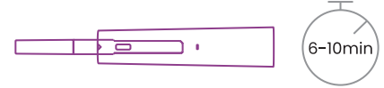
【TEST RESULT】
The measurement result will be displayed for 30 seconds.
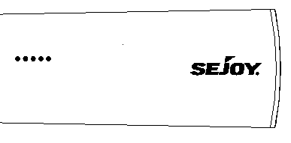
Symbol “-"
Indicates a negative result with a low probability of conception. For Luteinizing Hormone (LH), please test again after 12 hours. To ensure the accuracy of the tests, please test every day.

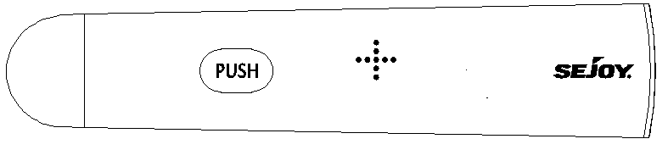
Symbol"+"
For Luteinizing Hormone (LH), when it detects the rise of LH for the first time, “+” will be displayed, which indicates a high probability of conception. Please test every 4-6 hours afterwards.
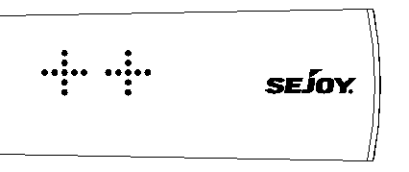
Symbol "++"
For Luteinizing Hormone (LH), LH surge is detected. And you have the highest probability of conception. Please keep testing every 4-6 hours until it shows “+”, which indicates that you have ovulated.
Symbol red ""
If red "" is displayed, it means that the instrument has an error;
Errors in detection may be due to:
·The the test midstream is not placed in a downward position, or the dipstick is not placed horizontally after urination.
·use too much or too little urine.
You should use a new dipstick to retest and follow the instructions.
If the red""continues to flash, replace the battery.

【LIMITATIONS】
- This test may not be used as a form of birth control.
- The test results should not be affected by pain relievers, antibiotics and other common drugs. Medication containing hCG or LH may affect the test and should not be taken while using the LH One Step Ovulation Test Midstream. In addition, the test will not work properly for subjects who are pregnant, in menopause, or are taking birth control pills.
【PERFORMANCE CHARACTERISTICS】
Sensitivity and Accuracy
Laboratory studies show that the sensitivity of the LH One Step Ovulation Test Midstream is 10mIU/mL and 20mIU/mL, the accuracy is 99.5%
Interference Substance
The following potentially interfering substances were added to LH negative and positive specimens.
Analyte | Concentration | Analyte | Concentration
Acetaminophen | 20mg/dl | Glucose | 2g/dl
Acetylsalicylic acid | 20mg/dl | Hemoglobin | 10mg/dl
Ascorbic acid | 20mg/dl | Ampicillin | 20mg/dl
Atropine | 20mg/dl | Tetracycline | 20mg/dl
Caffeine | 20mg/dl | Bilirubin | 2mg/dl
Gentisic acid | 20mg/dl
Cross Reactivity
The LH One Step Ovulation Test Midstream has been tested with commonly known drugs and hormones including FSH (200 mIU/mL), TSH (250 μIU/mL). At the levels tested, none of these substances interfered with the expected test results.
【QUESTIONS & ANSWERS】
1.Q: Can the LH One Step Ovulation Test Midstream be used to avoid pregnancy?
A: No, the test should not be used as a form of birth control.
2.Q: Do alcohol or common medications affect the test?
A: No, but a physician should be consulted if taking any hormonal medication. Also, recent oral contraceptive use, breastfeeding or pregnancy could affect the results.
3.Q: Once a positive result is obtained, when is the best time to have intercourse?
A: Ovulation is likely to occur within 24-36 hours. This is the most fertile time. Sexual intercourse within this time frame is advised.
4.Q: Does this test replace the basal body temperature method (BBT)?
A: The shift in basal body temperature primarily indicates that ovulation has already occurred. The LH One Step Ovulation Test Midstream indicates that ovulation is about to occur.
5.Q: Does a positive result guarantee a pregnancy after intercourse within the fertile days?
A: There are many factors that can affect the ability to become pregnant. Often it may be necessary to use the test kit for 3-4 months before achieving pregnancy. A physician should be consulted if pregnancy is not achieved after 3-4 months.
6.Q: What time of the day should I perform the test? Do I need to use first morning urine?
A: First morning urine is not recommended, but any other time of day is suitable. For best results, try to collect urine at approximately the same time each day.
7.Q: Will heavy intake of liquids affect the result?
A: Heavy intake of fluids prior to testing will dilute the hormone in urine. Limiting fluid intake for about two hours before collecting urine is suggested.
TEST RESULTS CHART
Test | Date | Collection time | Result
Day 1
Day 2
Day 3
Day 4
【BIBLIOGRAPHY】
- Elkind-Hirsch, K; Goldzieher, JW; Gibbons, WE and Besch, PK. Obstetrics and Gynecology, 67(3): 450-453, 1986.
- Hartman CG. 1932. Ovulation and the transport and viability of ova and sperm in the female genital tract. In Sex and In- ternal Secretions, ed. E Allen, pp. 647–88. Baltimore, MD: Williams & Wilkins
- Hisaw FL. 1947. Development of the graafian follicle and ovulation. Physiol. Rev. 27:95–119
of the rat ovarian follicle wall prior to ovulation. Biol. Reprod. 11:483–5038. Richards JS. 1994. Hormonal control of gene expression in the ovary. Endocr. Rev.15:725–519. Eppig JJ. 1991. Intercommunication between the mammalian oocytes and companion somatic cells. BioEssays 13:569– 3. Corner GW. 1963. The Hormones in Hu- 74 man Reproduction, pp. 33–75. New York: Athenum
- Espey LL. 1980. Ovulation as an inflammatory reaction—a hypothesis. Biol. Reprod. 22:73–106
- Espey LL, Lipner H. 1994. Ovulation. In The Physiology of Reproduction, ed. E Knobil, JD Neill, pp. 725–80. New York: Raven

Index of Symbols
 | Consult instructions for use |  |  | Tests per kit |  |  | Authorized Representative
 | For in vitro  diagnostic use only |  |  | Use by |  |  | Do not reuse
 | Store between 2-30°C |  |  | Lot Number |  |  | Catalogue number
 | Manufacturer |  | 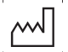 | Date of manufacturer |  |   0123 | Meet the requirements of 98/97/EC Directive
 | No exposure to the sun |  |  | No rain

Hangzhou Sejoy Electronics& Instruments Co.,Ltd.
Area C, Building 2, No.365, Wuzhou Road,Yuhang Economic
Development Zone,311100 Hangzhou City, Zhejiang,China
Website: www.sejoy.com


Shanghai International Holding Corp.GmbH (Europe)
Eiffestrasse 80, 20537 Hamburg, Germany
0123

