User Manual

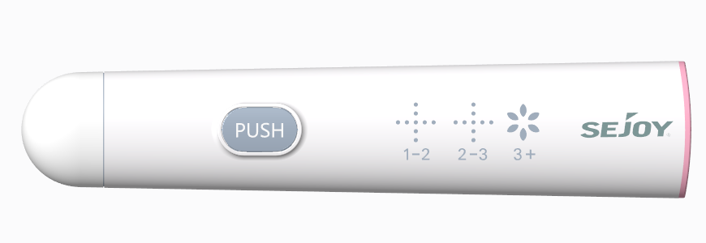



Digital Fertility Testing System
Model: FM-101L, FM-101H, FM-102, FM-103

For self-testing and and only for use outside the body




Table of Contents

1. Intended use 1
2. Test principle 1
3. Product illustration 2
4. Materials 2
5. Precautions 3
6. Warnings 4
7. Directions for use 4
8. Test result 6
9. Troubleshooting 7
10. Product specifications 7
11. Q&A 7
12. Warranty page 8
13. Electromagnetic Compatibility Information 8
14. Index of Symbol 10

Thank you for purchasing
For the safe use of this product, please read this User Manual first, and keep it properly after reading so that you may access and consult at any time. The warranty card is also included in the package. Please do not lose it.
- Intended use

The Sejoy Digital Fertility Testing System is composed of the Digital Fertility Tracker and Test Midstreams.The Digital Fertility Testing System is intended to be used for the quantitative or semi-quantitative detection hormone in human urine.
- Test principle
The Digital Fertility Testing System is a lateral flow sandwich immunochromatographic assay.During the test procedures,HCG,LH and/or FSH in the urine specimen reacts with the mouse antibody colloidal gold conjugate to form a complex.By capillary action,the complex migrates along the membrane to the monoclonal antibody line (T) and remains captured in the T line.The complex which is not captured by T-line will continue to migrate along the membrane to the polyclonal antibody line (C) and remains captured in the C line.A colored line will develop in the control zone is the basis for judging that the reagent chromatography process is normal.

The Digital Fertility tracker utilizes LED as a light source and light reflection to determine the presence or absence of the colored test and control lines.A procedure was implanted inside the device to judge negative and positive results and that the test results are displayed in symbolic form on the LED lamp of the device.According to the display color and the type of test midstream, the LH test midstream showed negative (-), positive (+), strong positive (++); FSH test midstream showed negative (-) and positive (+); HCG test midstream was negative (-) and positive (White “” ). If it was positive, it also showed 1-2, 2-3 and 3+ gestational weeks. The darker the color is, the higher the concentration of the corresponding hormone is, the greater the intensity of the absorbed light is, and the lower the intensity of the reflected light collected by the instrument is. The error status is displayed in red “”.

- Product illustration

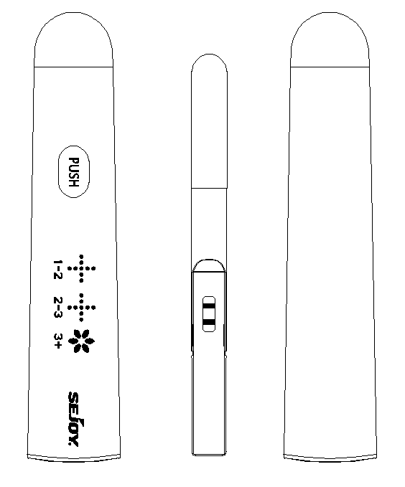
Lid of the
main body
Test midstream cover

Main body

PUSH button

LED display

Battery cover

Test midstream

Sejoy DFT-101 Digital Fertility Tracker consists of the main body, Lid of the main body, PUSH Button and battery cover.

- Materials
Please confirm what’s in the package you have purchased. The actual materials, especially the type of test midstream, will be up to which kind of kit you purchase.

Materials Provided

FM-101L:
- 1*DFT-101 Digital Fertility Tracker | - 1*CR2032 button cell | - 1*User manual
- 15*LH Test Midstream | - 1*Quick Guide

FM-101H:
- 1*DFT-101 Digital Fertility Tracker | - 1*CR2032 button cell | - 1*User manual
- 5*HCG Test Midstreams | - 1*Quick Guide

FM-102:
- 1*DFT-101 Digital Fertility Tracker | - 1*CR2032 button cell | - 1*User manual
- 5*HCG Test Midstreams | - 15*LH Test Midstreams | - 1*Quick Guide

FM-103:
- 1*DFT-101 Digital Fertility Tracker | - 1*CR2032 button cell | - 1*User manual
- 5*HCG Test Midstream | - 15*LH Test Midstreams | - 2*FSH Test Midstreams
- 1*Quick Guide

Materials Required But Not Provided

- Specimen collection container

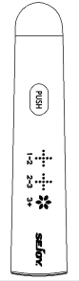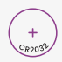
Main body Test midstream Battery User manual

- Precautions
- You can choose to use the urine of any of the three periods - morning, afternoon, or evening.
2. The test midstream in the bag should be used immediately after unpacking to avoid failure caused by dampness.
3. Stop drinking water 2 hours before collecting the urine sample to prevent it from being diluted.
4. There is a desiccant in the aluminum foil bag. Do not eat it.
5. Product expired may not be used.
6. Test midstream are disposable and cannot be reused.
7. Please discard the test midstream in a non-recyclable bin after use.
8. This product is for in vitro diagnostic use only.
9. This product is an auxiliary diagnostic device only. It cannot determine the actual amount of hormone in a urine sample. The test results cannot serve as a basis for diagnosis.
10. The test result will be displayed through the LED light. Once the test is completed, the icon will be displayed for 30 seconds before it goes out. If you want to check the result again, simply pull out the test midstream, or try to put the lid of DFT-101 back on and pull it out again. The result from your latest test will be shown.
11. Used test midstream, meter and the battery disposal must comply with the regulations of the national government and environmental protection agencies.
12. When there are stains, it is recommended to wipe with alcohol cotton or damp cloth.
13. Do not attempt to disassemble or repair the meter. Doing so may result in inaccurate readings.
14. If this product is used in a manner not specified by the manufacturer, the protection provided by the product may be impaired.
15. Please check the delivery information of products, including unpacking, completeness, and any damages during transport, and contact the customer services if any damages.
- Warnings
1.Any measurement done by this product is for personal reference only. It is very dangerous for a patient to conduct self-diagnosis and self-treatment based on measurements only. Please be sure to follow your doctor’s instructions.
2.Portable RF communications equipment (including peripherals such as antenna cables and external antennas) should be used no closer than 30 cm (12 inches) to any part of Digital Fertility Tracker, including cables specified by the manufacturer. Otherwise, degradation of the performance of this equipment could result.
3.Keep away hospitals except for near active HF SURGICAL EQUIPMENT and the RF shielded room of an ME SYSTEM for magnetic resonance imaging, where the intensity of EM DISTURBANCES is high.
4.Use of this equipment adjacent to or stacked with other equipment should be avoided because it could result in improper operation.
5.Use of accessories, transducers, and cables other than those specified or provided by the manufacturer of this equipment could result in increased electromagnetic emissions or decreased electromagnetic immunity of this equipment and result in improper operation.
6.Use of this instrument in a dry environment, especially if synthetic materials are present(synthetic clothing, carpets etc.) may cause damaging electrostatic discharges that may cause erroneous results.

- Directions for use
Step 1: Remove the battery cover. Install the button cell in the direction as indicated. Put the battery cover back in place. When you hear a beep, it indicates that the battery has been inserted successfully.
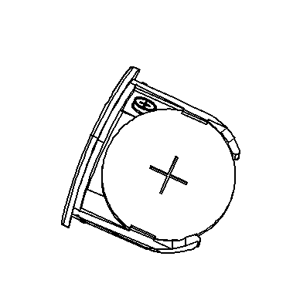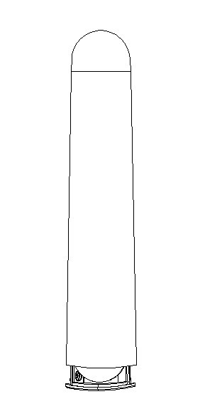
Step 2: Collect your urine in the cup. You can choose the urine from any of the three different time of the day - morning, afternoon, and evening.
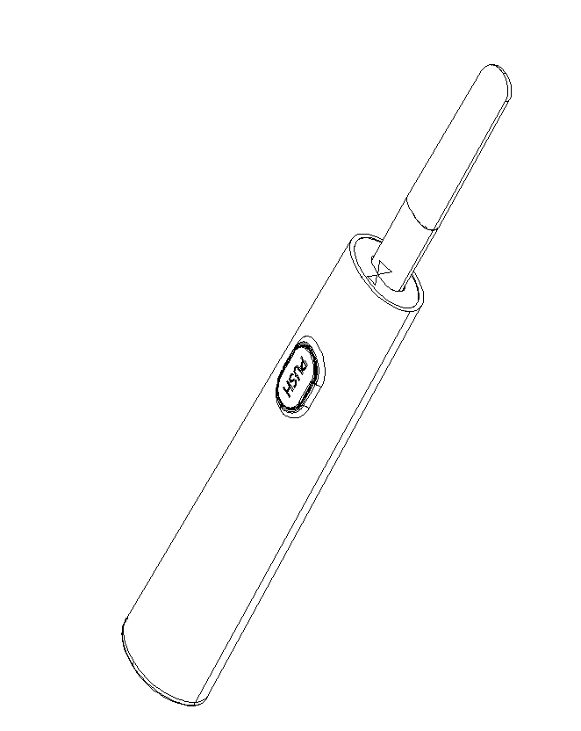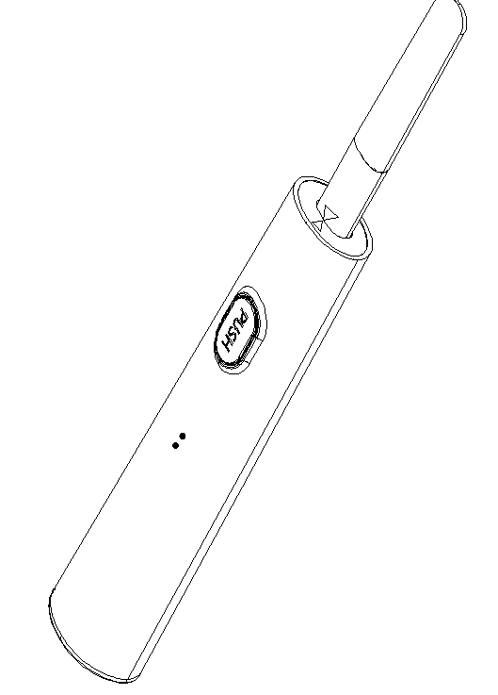
Step 3: Remove the lid of the main body. When you hear a beep or All lights are on (The indicator light goes out after 2s), it indicates that DFT-101 is on. Remove the test midstream cover and insert the test midstream into the device. (Please make sure that the test midstream is inserted all the way to the bottom and the whole arrow has disappeared.)or downward directly into your urine stream for at least 10-15 seconds.
In the left indicator area, the indicator light will flash alternately.
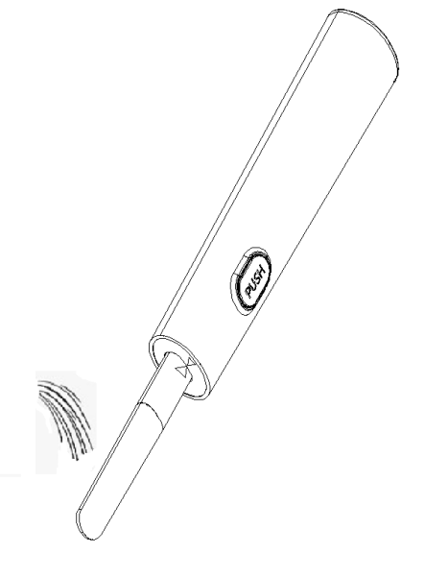
Step 4:Dip the top of the test midstream into the Urine and hold it until you hear a “beep” (In the left and right indication area, the indicator light will flash left and right circularly). Then pull it out and put the test midstream lid back on.
Note: But don’t drink too much liquid before testing.

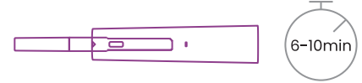

Step 5: Place the product on a flat surface. In the left and right indication area, the indicator light will flash left and right circularly during the testing. Wait for about 6-10 minutes till you hear three beeps which indicate that the test is completed. The test result will be out the test strip or putting back & pulling out the main body lid again will enable the last test result to show again.

- Test result
The measurement result will be displayed for 30 seconds and then turn off automatically.

For LH Midstream:
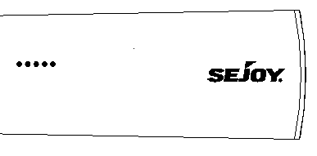  Symbol “-” | Indicates a negative result with a low probability of conception. For Luteinizing Hormone (LH), please test again after 12 hours. To ensure the accuracy of the tests, please test every day.
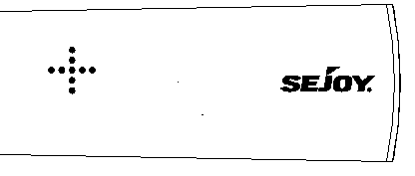  Symbol “+” | For Luteinizing Hormone (LH), when it detects the rise of LH for the first time, “+” will be displayed, which indicates a high probability of conception. Please test every 4-6 hours afterwards.
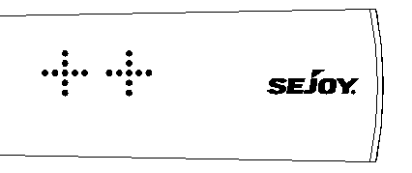  Symbol “++” | For Luteinizing Hormone (LH), LH surge is detected. And you have the highest probability of conception. Please keep testing every 4-6 hours until it shows “+”, which indicates that you have ovulated.

For FSH Midstream:
Symbol “-” | For FSH, “-” means your ovaries are functioning normally.
Symbol “+” | For Follicle Stimulating Hormone (FSH), “+” indicates the possibility of premature ovarian  failure, one more test is recommended, and please be sure to follow your doctor’s instructions if “+” is displayed again.

For HCG Midstream:
Symbol “-” | For HCG, “-” means non pregnant.
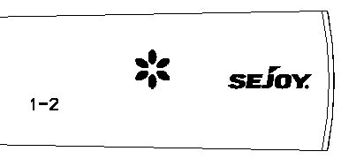  Symbol White “” | For human Chorionic Gonadotropin (HCG), you can assume that you are pregnant once White “” is displayed. At the same time, you can check the gestational weeks "1-2, 2-3, 3 +".

- Troubleshooting
Error message | Problem | Solution
Symbol red “”   | The test midstream is not placed in a downward position, or the dipstick is not placed horizontally after urination. | You should use a new dipstick to retest and follow the instructions.  If the red "" continues to flash, replace the battery.
 | Use too much or too little urine.
If there are still problems after restarting the instrument, please contact the manufacturer or local distributor.

- Product specifications
Product name: | Digital Fertility Tracker
Model: | DFT-101
Dimension: | 127.5mm*26.3mm*15.5mm
Weight: | 57g (Battery excluded)
Use environment: | Indoor use
Operation condition: | Temperature:10°C~40°C, RH: ≤85%
Transport and storage condition: | Temperature: -20°C~55°C, RH: ≤95%
Pollution degree: | Pollution degree 2
Service life: | 3 years (Battery excluded)
Battery: | 1*CR2032 Battery
Storage condition  of test midstream: | Temperature: 2°C~30°C(36°F~86°F)
Shelf life of test midstream: | 24 months
Altitude | Up to 10,000 feet (3,048 meters) above sea leve
Accuracy: | LH 99.5%, FSH 99.5%, HCG 99.3%

- Q&A
1. Q: How do I restart my DFT-101?
A: Remove the battery and battery cover, wait for 10 minutes, and then re-install the battery and battery cover
2. Q: Why is the testing duration not always the same?
A: The duration of the test is related to the amount of urine taken and the level of each hormone. But the test results will not be affected by the length of the testing time.

- Warranty page

Product model: |  | Remark:
Purchase data: |  | Point of sales:
3 years warranty is included under proper usage from date of purchase.
Under these circumstances, repair will be charged.
• Warranty expired.
• Warranty card not shown to seller.
• Vague information on warranty card.
Warranty does not cover
• Product surface damage
• Battery
• Damages caused by improper using habit
• Improper inspection and maintenance
• Other irresistible reasons.

- Electromagnetic Compatibility Information
The device satisfies the EMC requirements of the international standard IEC 60601-1-2 and IEC 61326-2-6.The requirements are satisfied under the conditions described in the table below. The device is an electrical medical product and is subject to special precautionary measures with regard to EMC which must be published in the instruction for use. Portable And mobile HF communications equipment can affect the device.Use of the unit in conjunction with non-approved accessories can affect the deice negatively and alter the electromagnetic compatibility.The device should not be used directly to or between other electrical equipment.
Table 1- EMISSION limits environment
Phenomenon | HOME HEALTHCARE ENVIRONMENT
Radiated RF EMISSIONS | CISPR 11 Class B

Table 2 ENCLOSURE PORT
Phenomenon | Basic EMC standard or test method | IMMUNITY TEST LEVELS
Electrostatic  discharge | IEC 61000-4-2 | ± 8 kV contact  ±2 kV,±4 kV,±8 kV,±15 kV air
Radiated RF EM  fields | IEC 61000-4-3 | 10 V/m (80 MHz – 2,7 GHz)  3 v/m (1GHz– 6GHz)  80 % AM at 1 kHz
Proximity fields from RF  wireless  communications  equipment | IEC 61000-4-3 | See Table 3.
RATED power frequency  magnetic fields | IEC 61000-4-8 | 30 A/m  50 Hz or 60 Hz

Table 3 Test specifications for ENCLOSURE PORT IMMUNITY to RF wireless communications equipment
Test frequency (MHz) | Band (MHz) | Service | Modulation | Maximum power(W) | Distance  (m) | Immunity test level(V/m)
385 | 380-390 | TETRA 400 | Pulse modulation  18Hz | 1.8 | 0.3 | 27
450 | 430-470 | GMRS 460  FRS 460 | FM  ± 5 kHz deviation  1 kHz sine | 2 | 0.3 | 28
710 | 704-787 | LTE Band 13, 17 | Pulse modulation  217Hz | 0.2 | 0.3 | 9
745
780
810 | 800-960 | GSM 800/900,  TETRA 800,  iDEN 820,  CDMA 850,  LTE Band 5 | Pulse modulation  18Hz | 2 | 0.3 | 28
870
930
1720 | 1700-1990 | GSM 1800.  CDMA 1900.  GSM 1900.  DECT.  LTE Band 1, 3,  4, 25; UMTS | Pulse modulation  217Hz | 2 | 0.3 | 28
1845
1970
2450 | 2400-2570 | Bluetooth,  WLAN,  802.11 b/g/n,  RFID 2450,  LTE Band 7 | Pulse modulation  217Hz | 2 | 0.3 | 28
5240 | 5100-5800 | WLAN 802.11  a/n | Pulse modulation  217Hz | 0.2 | 0.3 | 9
5500
5785

- Index of Symbol
Table of Symbol
 | Storage and transportation temperature limit |  | In vitro diagnostic medical device
 | Direct Current |  | Consult instructions for use
 | Manufacturer |  | Batch code
 | Contains sufficient for<n>tests |  | Authorized representative in the European Community
 | Serial number |  | Date of manufacture
 | Caution  consult in all cases where this symbol is marked. |  | The product is in compliance with the requirements of Directive 98/79/EC,  "0123" is the identification number of notify body.


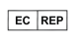
Document No.: DDFT-0104-002
Version:Z
Date of Issue: 2021.4

Hangzhou Sejoy Electronics & Instruments Co., Ltd.
Area C, Building 2, No.365, Wuzhou Road, Yuhang Economic Development Zone, Hangzhou City 311100 Zhejiang China
www.sejoy.com
Phone:+86-571-81957767
Email:info@sejoy.com

Shanghai International Holding Corp. GmbH (Europe)
Eiffestrasse 80, 20537 Hamburg, Germany

